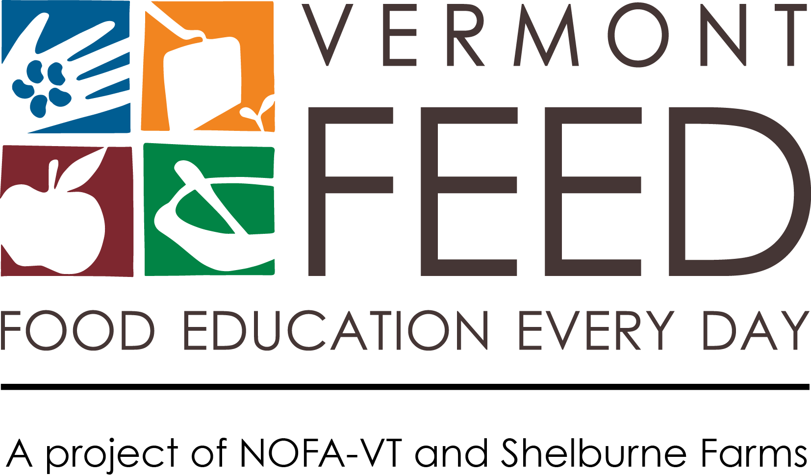
INSTITUTE MEDIA KIT

Congratulations on being selected for the 2019-2020 Northeast Farm to School Institute! As one of twelve new NEFTSI participants, your team will be helping to lead this important national movement, being among the nearly two million Northeast students that are engaging in Farm to School activities.

This media kit will help you spread the word about your school’s plans and activities and your selection for the Northeast Farm to School Institute. Publicizing your participation in the FTS Institute through local press and communication channels will help build support for your food, farm, and nutrition work – now and long-term.

In this kit you’ll find tips for media outreach and social media and a press release template. Please use and adapt them as you need!

Announcing Your Selection for the Northeast Farm to School Institute
Throughout this year, you’ll learn critical skills and practices that will help your students make healthier choices, increase local foods in the cafeteria, and draw innovative connections between classrooms, the cafeteria, and the community. We also want to help you grow your communications capacity, which is a critical part of successful programs. Publicity helps keep the community involved and informed, and media coverage demonstrates support for your project – critical pieces of getting broad-based community support and future funding.

Consider announcing your good news in the following ways:
- Sending a press release to local media outlets (see template on page 3)
- Sharing the news on Facebook, Twitter, Instagram and/or other social media avenues used by your community
- Posting a message on local listservs (e.g., Front Porch Forum)
- Putting an announcement in a community or school newsletter
5 Tips for Getting Press Coverage

We ♥ spreading
the word!

Use the hashtag #NEFTSI on Facebook, Twitter, and Instagram to share information about the 2019-20 Institute! Example posts:

Twitter: Exciting news! We're selected as a @VT_FEED 2019-20 NE #FarmToSchool Institute team! Learn more at: http://vtfeed.org/neftsi #NEFTSI

Facebook & Instagram: We've been selected as a 2019-20 Vermont FEED (Food Education Every Day) Northeast Farm to School Institute team! We’re excited to expand our work connecting students to local agriculture and the food they eat. #NEFTSI

Follow our social media channels:
Fb: www.facebook.com/vtfeed
Tw: www.twitter.com/vt-feed
Ig: www.instagram.com/vermont_feed
Mention or tag us, and we’ll share information about your project.

- Get to Know Local Press.
Read your local paper and other media to get a sense for what kinds of stories they cover. Find ways to connect your story to big local issues and themes. Learn your paper’s editorial calendar and find out how far in advance (often three weeks!) they need to know about stories or announcements. If you get press coverage, please contact us (info@vtfeed.org) so that we can help spread the good word.

- Get to Know Local Reporters.
Find out who covers the news for your town or school and reach out with an email or phone call. Meet up for coffee and tell reporters about your program, or invite them for a tour of the garden and lunch at school. Make yourself available to answer questions.
- Offer Great Content.
Reach out with great stories or events and include a “hook” to draw in the reader. Share photographs and multimedia. Send copies of posters, fliers, and other materials. Develop an elevator pitch and arm yourself with great stories about impact and results.

- Develop a Media Kit.
Make it easy for media to cover your project by developing a simple media kit. Pull together basic information about your project (include key quotes and stories to illustrate the importance of your program), photographs, logo, and contact information. Have it ready to send out at a moment’s notice, or post it online so reporters can find it easily.

- Share the Love.
Share your news and ask others to spread the word. Have students, community members, and project participants write stories or editorials and contact the paper. Tell the world about the coverage you’ve received! Join your state FTS listservs to post events. (Vermont schools can go to www.vermontfarmtoschool.org. Look for similar lists in your state.)
Press Release

The Vermont FEED and Shelburne Farms media relations team will be crafting a template press release for your team to send to your local papers to announce your participation in this year’s Institute. We will share the template in the coming weeks and will reach out when this is available!

