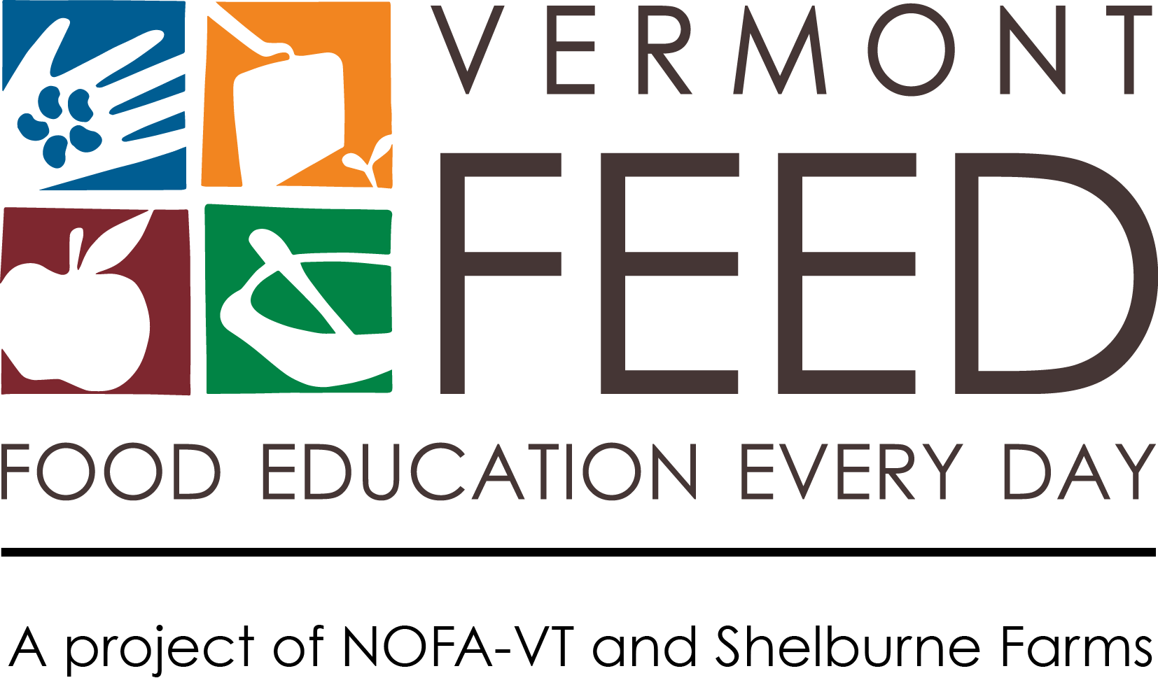
INSTITUTE MEDIA KIT

Congratulations on being selected for the 2018-2019 Northeast Farm to School Institute! As one of twelve new FTS Institute participants, your team will be helping to lead this important national movement, being among the nearly two million Northeast students that are engaging in Farm to School activities.

This media kit will help you spread the word about your school’s plans and activities and your selection for the Northeast Farm to School Institute. Publicizing your participation in the FTS Institute through local press and communication channels will help build support for your food, farm, and nutrition work – now and long-term.

In this kit you’ll find tips for media outreach and social media and a press release template. Please use and adapt them as you need!

Announcing Your Selection for the Northeast Farm to School Institute
Throughout this year, you’ll learn critical skills and practices that will help your students make healthier choices, increase local foods in the cafeteria, and draw innovative connections between classrooms, the cafeteria, and the community. We also want to help you grow your communications capacity, which is a critical part of successful programs. Publicity helps keep the community involved and informed, and media coverage demonstrates support for your project – critical pieces of getting broad-based community support and future funding.

Consider announcing your good news in the following ways:
- Sending a press release to local media outlets (see template on page 3)
- Sharing the news on Facebook, Twitter, Instagram and/or other social media avenues used by your community
- Posting a message on local listservs (e.g., Front Porch Forum)
- Putting an announcement in a community or school newsletter

5 Tips for Getting Press Coverage

Spread
the word!

Use the hashtag #NEFTSI on Facebook, Twitter, and Instagram to share information about the 2018-19 Institute! Example posts:

Twitter: Exciting news! We're selected as a @VT_FEED 2018-19 NE Farm to School Institute team! Learn more at: http://vtfeed.org/neftsi #NEFTSI

Facebook & Instagram: We've been selected as a 2018-19 Vermont FEED (Food Education Every Day) Northeast Farm to School Institute team! We’re excited to expand our work connecting students to local agriculture and the food they eat. #NEFTSI

Follow our social media channels:
Fb: www.facebook.com/vtfeed
Tw: www.twitter.com/vt-feed
Ig: www.instagram.com/vermont_feed
Mention or tag us, and we’ll share information about your project.

- Get to Know Local Press.
Read your local paper and other media to get a sense for what kinds of stories they cover. Find ways to connect your story to big local issues and themes. Learn your paper’s editorial calendar and find out how far in advance (often three weeks!) they need to know about stories or announcements. If you get press coverage, please contact us (info@vtfeed.org) so that we can help spread the good word.

- Get to Know Local Reporters.
Find out who covers the news for your town or school and reach out with an email or phone call. Meet up for coffee and tell reporters about your program, or invite them for a tour of the garden and lunch at school. Make yourself available to answer questions.
- Offer Great Content.
Reach out with great stories or events and include a “hook” to draw in the reader. Share photographs and multimedia. Send copies of posters, fliers, and other materials. Develop an elevator pitch and arm yourself with great stories about impact and results.

- Develop a Media Kit.
Make it easy for media to cover your project by developing a simple media kit. Pull together basic information about your project (include key quotes and stories to illustrate the importance of your program), photographs, logo, and contact information. Have it ready to send out at a moment’s notice, or post it online so reporters can find it easily at any time.

- Share the Love.
Share your news and ask others to spread the word. Have students, community members, and different people on your project write stories and editorials or contact the paper to demonstrate that it is truly a team effort. Tell the world about the coverage you’ve received! Develop a social media campaign and join your state FTS listservs to post events. (Vermont schools can go to www.vermontfarmtoschool.org. Look for similar lists in your state.)
Press Release Template

The Vermont FEED and Shelburne Farms media relations team will be putting out a press release to your local papers to announce your participation in this year’s Institute.

Below is the press release template we used to reach out to local papers in your area. Please use the information from this release to pull from in your own future press outreach, and as a general format guide. It is important to share the projects, community events, and achievements of your Farm to School Action Plan throughout the school year and beyond to connect with your community and show the power of Farm to School programming. We suggest adding facts, quotes, and details about the work you’re promoting, and then sending it to press contacts in the body of an email.

Email Subject PRESS RELEASE: TITLE

FOR IMMEDIATE RELEASE

DATE

CONTACT
Name
Title
Organization
Phone
Email

School Selected For Program to Grow School-wide Farm to School Initiatives
School is one of twelve teams recently selected for the fourth annual Northeast Farm to School Institute. Shelburne Farms and NOFA-VT are offering a year-long professional development program supporting selected schools from across the Northeast in design, development, and implementation of effective, school-wide Farm to School programs. Through their Vermont FEED initiative, Shelburne Farms and NOFA-VT’s’ Northeast Farm to School Institute advances food, farm, and nutrition education and expands student access to healthy, local products in school cafeterias.
Twelve schools from across New England and New York state were selected following a competitive application process, which demonstrated to the selection committee the schools’ commitment and readiness to realize a viable Farm to School program by the program’s year end.

Insert quote from School official, farm to school coordinator, or other spokesperson about why your team is participating in the Institute or what you hope to get out of it.

Consider inserting info about your current Farm to School activities and/or your plans. For example, how much local food is already served in your school, recent accomplishments, what your goals are and/or what farms you partner with.

The success of the Institute has attracted national attention. FTS leaders from various states are observing the Institute with the goal of adapting this model to their own states’ need, which includes leaders from all six New England states, New York, Mississippi, Georgia, and the USDA. “As an early leader in Farm to School, Vermont has many lessons learned to share with other states. In the past, Vermont’s Farm to School grants program, which was the first in the country, was used as a model as the USDA developed the National Farm to School Grant Program,” said Betsy Rosenbluth, Vermont FEED Project Director. “We’re excited to now share our Institute as a model for whole-school professional development for Farm to School.”
Vermont has long championed Farm to School (FTS) efforts, and as federal nutrition standards are being rolled back, this small state is stepping into the breach, and modelling success for others. The Institute is part of that model. Senator Patrick Leahy (D-Vt.), a leading champion for Farm To School efforts on the Senate Appropriations Committee, said: “Around Vermont, children are eating healthier meals at school because Farm to School connects students to fields, and farmers to classrooms. I’m proud to have been able to take Vermonters’ fresh ideas about the Farm to School movement to Capitol Hill and to turn our state’s experience into action. With the Farm to School Institute, communities from across our region can share in the program’s success and realize the health benefits that come when children enjoy fresh, locally grown food at school.”
During the Institute’s kick-off, three-day intensive , teams of food service staff, educators, administrators, and community partners will meet with peers and experts to expand their understanding and practices of FTS. Teams will develop an action plan for the coming school year in collaboration with an experienced FTS coach and continue working with their coach throughout the 2018-2019 school year to implement their programs and integrate best practices (farm visits, gardening and cooking activities, serving seasonal foods in school cafeterias, and offering food-based, hands-on science, math, and literacy lessons).
Over eight years, the Institute has supported FTS programs at 74 schools and districts, reaching over 54,000 Northeast students. The Institute also plays a major role in achieving the Vermont Farm to School Network's ambitious statewide goal for growth: By 2025, 75 percent of schools will engage in integrated FTS programing, and 50 percent of school food will be purchased from local or regional sources.
According to the 2016 Vermont School Health Profiles, 92% of Vermont schools now serve some locally grown foods; while three out of four have school gardens and that number continues in an upward trend. These trends hope to chip away at a more sobering statistic: one in four Vermont teens is now obese or overweight. Beyond the classroom, a recent report commissioned by the Vermont Agency of Agriculture, Food, and Markets found that every dollar spent by schools to purchase local food contributes $1.60 to the local economy.
The 2018-2019 Northeast Farm to School Institute has school teams from all seven Northeast states. The twelve participating schools are: Rombout Middle School, Beacon, NY; Bennington County Head Start, Bennington, VT; Captain Albert Stevens School, Belfast, ME; Codman Academy Charter Public School, Dorchester, MA; Groton Public Schools, Groton, CT; Hamburg Central School District, Hamburg, NY; Kenneth A. Brett School, Tamworth, NH; Lamoille North Modified Unified Union School District, Hyde Park, VT; Mt Pleasant High School, Providence, RI; Peoples Academy & Morristown Elementary School, Morristown, VT; Schoharie Central School, Schoharie, NY; Sidney Central School District, Sidney, NY.
Insert your school’s boilerplate language here – one paragraph summarizing your organization, mission, and website or phone number. Add a separate paragraph for any additional partners on your Farm to School work.
Vermont FEED is a Farm to School partnership project of Shelburne Farms and Northeast Organic Farming Association of Vermont (NOFA-VT). Their “3C Model” catalyzes change through the Cafeteria, Classroom, and Community to improve knowledge, attitudes, and behaviors toward healthy eating, local purchasing, and our food system.
Shelburne Farms is a nonprofit organization whose mission is to cultivate and inspire learning for a sustainable future. That means learning that links knowledge, inquiry, and action to help students build a healthy future for their communities and the planet. Shelburne Farms’ campus is a 1,400-acre working farm, forest, and National Historic Landmark. For information, please visit shelburnefarms.org.
####

