(School/District/SU) seeks to purchase: (brief description of products)

Our Farm to School and Nutrition Program values: (these are examples, feel free to use these or your own)
- Access to nutritious, safe, healthy and delicious food is paramount for the success of students.
- We honor the work of our farmers and value the importance of connecting to local farms and agriculture.
- Providing health and nutrition educational opportunities for students is part of the overall educational experience.
- A program that fosters student ownership of healthy eating habits that also develops connections to (and stewardship of) their community, their environment, and their local economy.
Common Specifications for Local & Values Based Purchasing

Drafting specifications helps you communicate your desired products and conditions with farmers and producers. The following examples target local without requiring it. These could be used as a product specification in your Farm to School Procurement Inquiry:
- Particular varieties unique to the region
- Freshness (e.g. Delivered within 48 hrs)
- Small or medium-sized farm
- Certified Organic
- Grass Fed
- GMO Free
- Fair labor practices
- Origin labeling
- Able to provide farm visits or class visits
Product | Specifications | Quantity | Frequency | Other Requirements
Examples: beef, dairy, maple, eggs, produce, etc. | Examples: preferred & accepted sizes; grade; variety, etc. | Examples: pounds; cases; etc. | Examples: weekly, monthly, etc. | Examples: delivery; source identification; education opportunities; food safety plan; notification of order changes, etc.

Delivery Required?
☐ Yes | Delivery Location(s) and Time: (Ex: “Town High School & Town Elementary School, weekdays 7:00 AM - 3:00 PM”)
☐ No | Specify pick up arrangement: (Ex: “School nutrition van can pick up on Wednesdays”)

Buy American: The Buy American provision requires schools to purchase domestically grown and processed foods
to the maximum extent practicable. Domestic products are defined as agricultural commodities that are produced
in the United States.
Geographic Preference:
Use this statement IF you want to use Geographic Preference. Find more information on Geographic Preference here.

Our definition of Local is (insert your own definition of local). We will apply Geographic Preference for the products listed above.

The price percentage for geographic preference means that for the purposes of comparison only, prices for products grown within the tiers will be adjusted according to the outlined 2 tiers. The price percentage preference affects the quoted price only for awarding of the quote, not the actual price paid to the producer. (This is an example; tiers are defined by school or district.)

Tier one: X% discount for products from ________Vermont.
Tier two: X% discount for products from ________Vermont.

The price preference will be applied when evaluating bids, but will not change the actual quoted and paid price for the beef.
_______________________________________________________________________________________________________________________________________________________________
Example Only:
Tier one: Beef cattle raised in Vermont in Addison County (10% price preference** on quoted price)

Tier two: Beef cattle raised in VT but outside of the Vermont county listed above (5% price preference on quoted price)

*NOTE: The price preference will be applied when evaluating bids, but will not change the actual quoted and paid price for the beef.

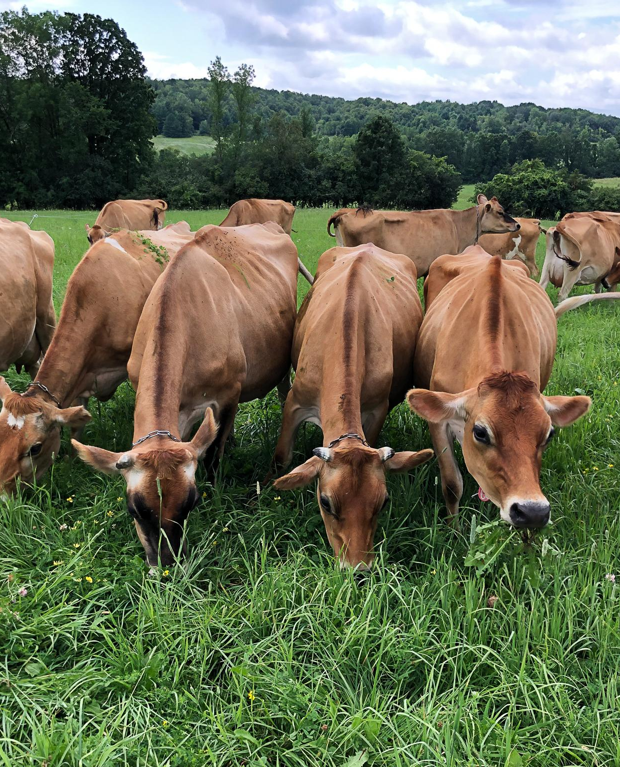 | 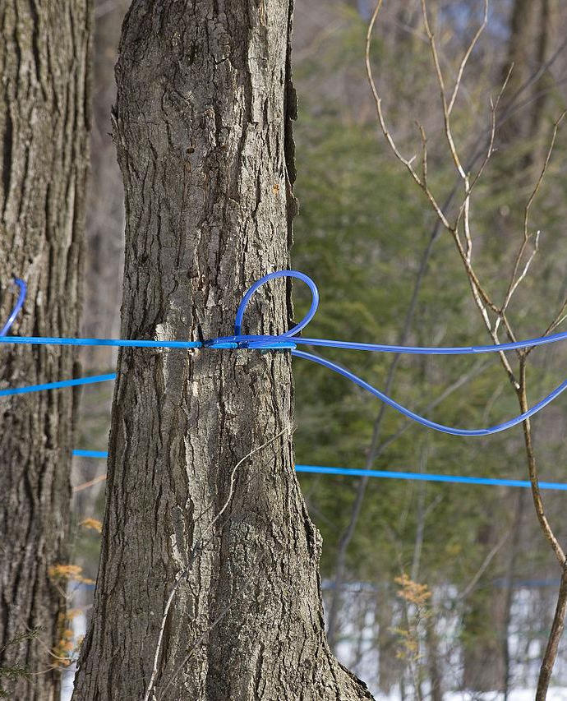 | 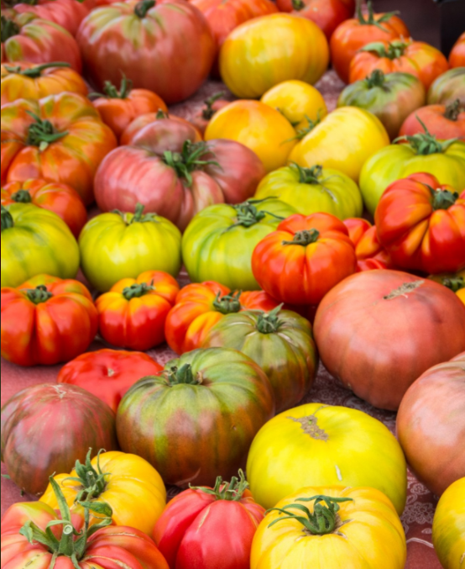 | 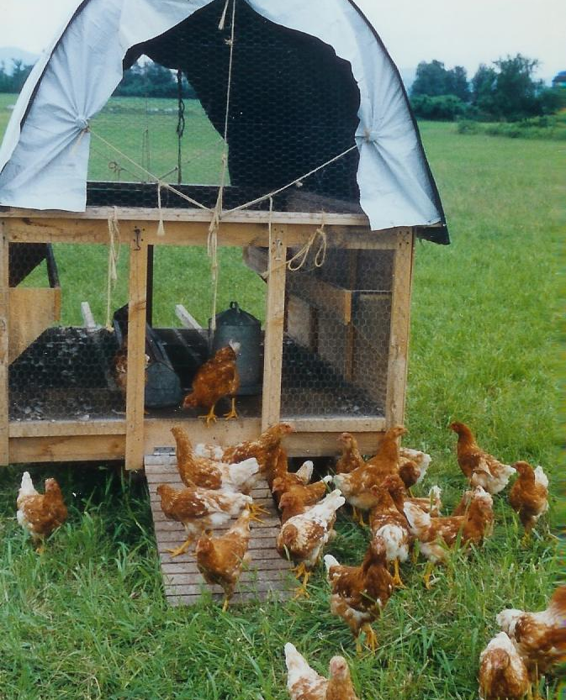
Farmer / Producer Information:
Contact Name | Farm Name | Farm Address | Phone: | Email:

Instructions:
School/District/SU: Please copy and paste product info from your Procurement Inquiry Form on the previous page on the highlighted rows.
Vendor: Please select which of the vendor criteria you can fulfill and write in your product availability and price in the orange columns.

Product | Specifications* | Quantity | Frequency | Other Requirements | Availability | Vendor Price
Ex: Beef, Dairy, Maple, Eggs, Produce | Ex: Preferred & accepted sizes; Grade; Variety | Ex: pounds; cases; etc. | Ex: weekly, monthly, etc. | Ex: delivery; source identification; education opportunities; food safety plan; notification of order changes, etc. | Projected Availability by Month or Season | Delivery price included?
{Insert Product Info} |  |  |  |  | Vendor Response: | Vendor Response:
Vendor Response: Select | Vendor Response:  Select | Vendor Response:  Select | Vendor Response:  Select | Vendor Response:  Select
{Insert Product Info} |  |  |  |  | Vendor Response: | Vendor Response:
Vendor Response: Select | Vendor Response:  Select | Vendor Response:  Select | Vendor Response:  Select | Vendor Response:  Select
{Insert Product Info} |  |  |  |  | Vendor Response: | Vendor Response:
Vendor Response: Select | Vendor Response:  Select | Vendor Response:  Select | Vendor Response:  Select | Vendor Response:  Select
{Insert Product Info} |  |  |  |  | Vendor Response: | Vendor Response:
Vendor Response: Select | Vendor Response:  Select | Vendor Response:  Select | Vendor Response:  Select | Vendor Response:  Select

Additional Information:
Payment Terms and Invoice Process: (School/District/SU: Provide your invoicing and payment process here.)
Please respond by: (School/District/SU: insert date vendor should respond by.)
Please submit responses and direct questions to: (School/District/SU: insert your contact information.)

NOTICE: Vendors, please be advised that submission of this form is not a guaranteed sale. The more requirements and specifications that vendors can meet will increase their chances of being selected.

