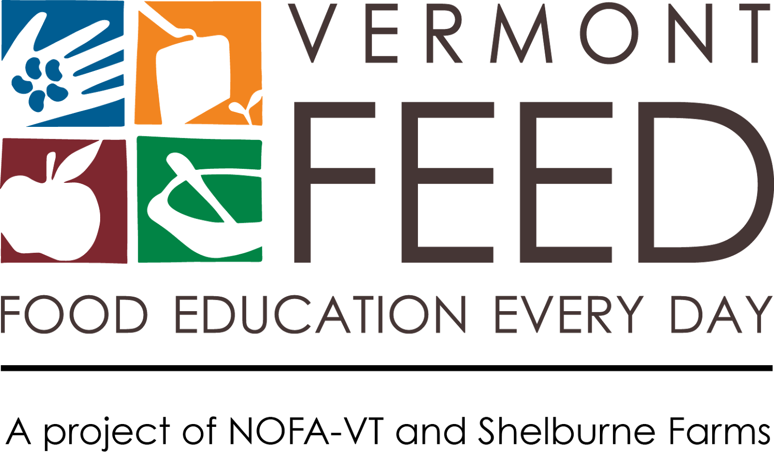
MEDIA KIT

Congratulations on being selected for the 2017-2018 Northeast Farm to School Institute! As one of twelve new FTS Institute participants, your team will be helping to lead this important national movement, being among the nearly two million Northeast students that are engaging in Farm to School activities.

This media kit will help you spread the word about your school’s plans and activities and your selection for the Northeast Farm to School Institute. Publicizing your participation in the FTS Institute through local press and communication channels will help build support for your food, farm, and nutrition work – now and long-term.

In this kit you’ll find tips for media outreach and social media and a press release template. Please use and adapt them as you need!

Announcing Your Selection for the Northeast Farm to School Institute
Throughout this year, you’ll learn critical skills and practices that will help your students make healthier choices, increase local foods in the cafeteria, and draw innovative connections between classrooms, the cafeteria, and the community. We also want to help you grow your communications capacity, which is a critical part of successful programs. Publicity helps keep the community involved and informed, and media coverage demonstrates support for your project – critical pieces of getting broad-based community support and future funding.

Consider announcing your good news in the following ways:
- Sending a press release to local media outlets (see template on page 3)
- Sharing the news on Facebook, Twitter, Instagram and/or other social media avenues used by your community
- Posting a message on local listservs (e.g., Front Porch Forum)
- Putting an announcement in a community or school newsletter

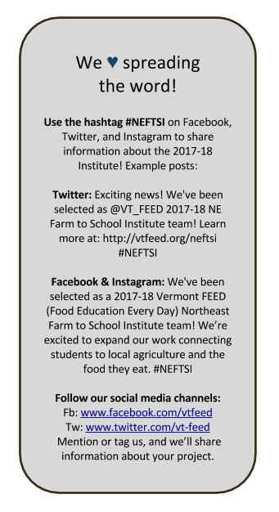
5 Tips for Getting Press Coverage

1. Get to Know Local Press.
Read your local paper and other media to get a sense for what kinds of stories they cover. Find ways to connect your story to big local issues and themes. Learn your paper’s editorial calendar and find out how far in advance (often three weeks!) they need to know about stories or announcements. If you get press coverage, please contact us (info@vtfeed.org) so that we can help spread the good word.

2. Get to Know Local Reporters.
Find out who covers the news for your town or school and reach out with an email or phonecall. Meet up for coffee and tell reporters about your program, or invite them for a tour of the garden and lunch at school. Make yourself available to answer questions.
3. Offer Great Content.
Reach out with great stories or events and include a “hook” to draw in the reader. Share photographs and multimedia. Send copies of posters, fliers, and other materials. Develop an elevator pitch and arm yourself with great stories about impact and results.

4. Develop a Media Kit.
Make it easy for media to cover your project by developing a simple media kit. Pull together basic information about your project (include key quotes and stories to illustrate the importance of your program), photographs, logo, and contact information. Have it ready to send out at a moment’s notice, or post it online so reporters can find it easily at any time.

5. Share the Love.
Share your news and ask others to spread the word. Have students, community members, and different people on your project write stories and editorials or contact the paper to demonstrate that it is truly a team effort. Tell the world about the coverage you’ve received! Develop a social media campaign and join your state FTS listservs to post events. (Vermont schools can go to www.vermontfarmtoschool.org. Look for similar lists in your state.)
Press Release Template

Feel free to use and adapt the following template to create a press release announcing your selection for the 2017-2018 Northeast Farm to School Institute. We suggest personalizing underlined sections with facts, quotes and details about your program, and then sending it to press contacts in the body of an email.

Email Subject PRESS RELEASE: TITLE

FOR IMMEDIATE RELEASE

DATE

CONTACT
Name
Title
Organization
Phone
Email

School Selected for 2017-2018 Northeast Farm to School Institute

School is one of twelve teams recently selected for the third annual Northeast Farm to School Institute, hosted by Vermont Food Education Every Day (Vermont FEED). The Institute is a year-long learning opportunity that will help school advance their initiatives in food, farm, and nutrition education while serving local products in the cafeteria. Institute schools serve as model programs in their states for other school districts to learn from.

Farm to School in the Northeast is reaching nearly two million students, and Northeast schools spent nearly $70 million on local foods in one year, according to the USDA Farm to School Census. Farm to School helps grow the region’s economy, not only as a market opportunity for farmers and producers, but also to help grow future generations of consumers tied to local products. Farm to school also improves our children’s health by increasing their consumption of fruits and vegetables — a recognized obesity prevention strategy. Additionally, Farm to School helps reduce childhood hunger by contributing to the expansion and success of school nutrition programs.

Insert quote from School official, farm to school coordinator, or other spokesperson about why your team is participating in the Institute or what you hope to get out of it.
Consider inserting info about your current Farm to School activities and/or your plans. For example, how much local food is already served in your school, recent accomplishments, what your goals are and/or what farms you partner with.

Beginning with a summer workshop at Shelburne Farms, school food service staff, teachers, administrators, and community partners will meet with peers and experts in the field to expand their understanding and practices of Farm to School and develop a farm to school action plan for the coming school year. The schools are matched with an experienced Farm to School coach to help the school implement their plan. The plans integrate best practices into school programs, such as farm visits, gardening and cooking activities, serving seasonal foods in school cafeterias, and offering food-based, hands-on science, math, and literacy lessons. School’s team includes: list team members and roles.
The Northeast Farm to School Institute has supported the development of Farm to School programs at 62 schools and districts, reaching over 38,000 students from the Northeast. Senator Patrick Leahy (D-VT), champion of the Healthy, Hunger-Free Kids Act of 2010 and Farm to School Act of 2015, said:

“Farm to School programs have proven incredibly useful in forging ways to connect our food, our communities and our own health. We have made considerable progress in advancing this movement since I first established mandatory federal support for this program as part of the Healthy and Hunger Free Kids Act in 2010. There is no better place for the Farm to School Institute than the Green Mountain State. Year after year, USDA has cited Vermont as the place to learn how educators, cooks, and families can work together to keep our kids healthy. Federal partnership programs like this were made to help people, regardless of background, or income. With Farm to School, we are helping to raise the next generation of mindful, healthy, hunger-free families with every dollar we invest.”

Highlight accomplishments from last year’s Institute school teams include: increasing local procurement of seafood including lobster, clams and scallops (Seabrook School District, NH); developing a community-wide Grow-a-Row program in the school gardens (Newbury Elementary, VT); creating hydroponic gardens in the school cafeteria (New London, CT); establishing a fresh fruit and vegetable grab-n-go snack option (Vernon-Verona-Sherril Schools, NY); establishing garden-based capstone projects for AP environmental science classes (Holyoke High School, MA); and construction of a school sugarhouse (Lyndon Institute, VT). It comes as no surprise that Northeast states are in the top 15 percent of farm to school participation efforts nationally, according to the recently released USDA Farm to School survey.

The 2017-2018 Northeast Farm to School Institute has school teams from all seven Northeast states. The twelve participating schools are: Berlin Elementary School (Berlin, VT), Vermont School for Girls (Bennington, VT), Harwood Union High School (Moretown, VT), Springfield School District (Springfield, VT), Providence Public School District (Providence, RI), Johnson City Central School District (Johnson City, NY), Saranac Lake Middle School (Saranac Lake, NY), Nashua, NH School District (Nashua NH), Witchcraft Heights Elementary School (Salem, MA), Albert S. Hall School (Waterville, ME), Charles Barnum Elementary School (Groton, CT), and Mayberry Elementary (East Hartford, CT).

To learn more about the Northeast Farm to School Institute, please visit www.vtfeed.org.
# # #

Insert your school’s boilerplate language here – one paragraph summarizing your organization, mission, and website or phone number. Add a separate paragraph for any additional partners on your Farm to School work.

Vermont Food Education Every Day (VT FEED) is a partnership program of Shelburne Farms and the Northeast Organic Farming Association of Vermont (NOFA-VT). VT FEED’s mission is to work with schools and communities to raise awareness about healthy food, good nutrition, and the role of farms and farmers. Visit www.vtfeed.org to learn more.

